EQUITAS ACADEMIES TRUST



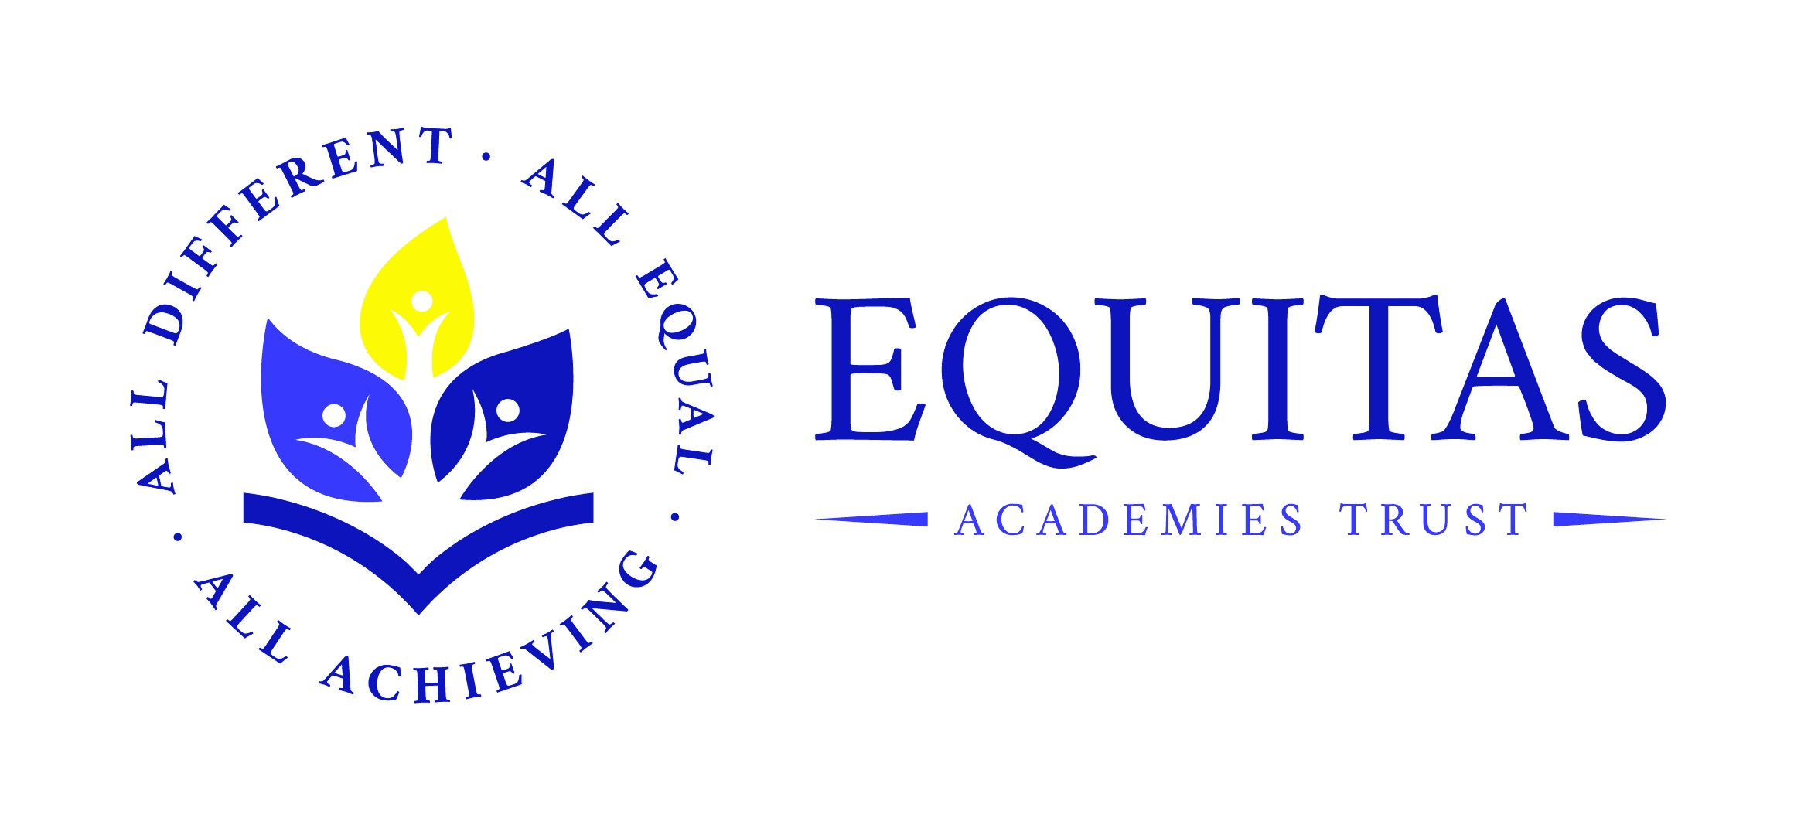

Chilwell Croft Academy

RELATIONSHIP & HEALTH EDUCATION POLICY

Review Date: | November 2024
To be Reviewed: | November 2025
Agreed: | Raising Standards
Policy Lead: | Deputy Headteacher

Relationship & Health Education Policy

Contents Page

1. School Vision and Rationale 3

2. Overview of Relationships and Health Education 3

3. School Context 3

4. Policy Development and Consultation 3

5. School Experiences 4

4. What is Relationship Education at CCA? 4

5. Aims and Objectives 4

6. School Values 4

6. Content of Programme 5

7. Organisation and Methods of Teaching 5

7. Planning and Delivery of Programme 5

8. Resources 5

8. Areas of responsibility 5-6

9. Specific issues 6

10. Working with Parents 7

11. Parent withdrawal 7

12. Provision for Menstruation 7

13. Other related documents and policies 7

14. Equal opportunities/inclusivity 7

15. Monitoring and Evaluation 7

16. Dissemination of the Policy 8

RELATIONSHIP & HEALTH EDUCATION POLICY

School Vision and Rationale

At Chilwell Croft Academy, our aim is to equip our pupils with the skills, knowledge
and understanding to become healthy, resilient, independent and responsible members of society as well as global citizens who are informed and active.

We support each pupil to ensure they can thrive and succeed academically, socially and emotionally. Relationship and Health Education (RHE) is a fundamental part of our Personal Social Health Education (PSHE) curriculum for pupils in our school; it is embedded in our PSHE curriculum.

Through all aspects of the RHE curriculum we promote the spiritual, moral, cultural, mental and physical development of pupils at school and in society by preparing our pupils for the opportunities, responsibilities and experiences whilst growing up.

We believe that it is vital that our pupils are educated about changes they will go through and for them to understand what makes a healthy relationship.

Overview of Relationships Education and Health Education
Relationships Education and Health Education became compulsory in schools from September 2020. We believe that the teaching of these areas is an ongoing process, which should start at home and continue at school. This process should happen in partnership with parents so, a positive effort is made to inform and involve parents throughout. Themes covered through Relationships Education and Health Education complement each other and link to other National Curriculum subjects.

School Context
The ethnicity of our pupils and families is diverse with the vast majority of pupils having English as an additional language. Within our holistic approach we have identified key groups of pupils as priorities for the school: SEND, PP, EAL and pupils living in temporary accommodation.

Our curriculum meeting the needs of our context is paramount and we seek to provide aspirational and creative curriculum opportunities. We aim to ensure respect for selves and being part of local community and society.

Policy Development and Consultation
This policy has been developed through consultation with school stakeholders which include: staff, pupils, parents and external agencies.

The policy has paid due regard to issues related to National Health Targets, the safeguarding of its pupils including CCE, CSE, FGM and Homophobia and all protected characteristics from the Equality Act 2010.

School Experiences
Throughout their time at Chilwell Croft, pupils are provided with a wealth of opportunities and experiences including workshops provided by SCARF (PSHE resources)and age-appropriate puberty sessions.

What is Relationship Education at Chilwell Croft Academy?
- It is lifelong learning about the way relationships develop and grow over time from childhood through to adult relationships.
- It is about the understanding and importance of relationships and the values, qualities and responsibilities in friendships, families, loving relationships and how to develop an understanding of safety in all types of relationships. It promotes self respect, confidence, respect & responsibility toward others, marriage, loving relationships, safety, love and care.
- It is also about the teaching of puberty and the changes that occur as young people move into adolescence.
- It is not teaching about sex education.

Aims and Objectives
- To provide clear guidance for parents, staff and governors in relation to the PSHE programme progression and delivery.
- To develop the understanding of healthy relationships.
- To develop perseverance and resilience, helping pupils to respect themselves and others.
- To support pupils through their physical, emotional and moral development.
- To develop skills and understanding to enable pupils to make healthy, responsible choices about their health and well being including personal hygiene.
- To help pupils move more confidently and responsibly into and through adolescence.
- To help pupils to understand issues of media influence and mixed messages that may contradict and conflict with own beliefs.
- To provide a foundation for further work at secondary school.

School Values
Our School Values underpin our school system which centres around our community needs and ensuring our pupils are supported to achieve their best.
School Values are launched by members of the senior leadership team at the start of each month.

The School Values are displayed around school and referenced in daily life linked to our curriculum offer.

Content of Programme
Relationships Education and Health Education complement each other as part of a comprehensive programme and whole school approach to safeguarding our pupils.

The key areas of Relationships Education coverage are:

- Families and people who care for me,
- Caring friendships,
- Respectful relationships,
- Online relationships and
- Being safe.

Department for Educaton

Organisation and Methods of Teaching
Weekly PSHE (Personal, Social, Health Education) lessons are timetabled and these continue throughout focus weeks for Computing, Religious Education and Science. PSHE lessons incorporate special weeks, for example Parliament Week and Anti-Bullying Week.

Planning and delivery of programme.
The programme is taught by class teachers with supporting staff - this ensures that both pupils and staff are protected.
The discrete puberty programme of puberty will be taught in Year 5 & 6 in selected single gender group by Birmingham City Council’s Lead PSHE Consultant.
Resources used have been selected through the parent and staff partnership and materials are shared as part of year group workshops.

Resources
SCARF (Safety, Caring, Achievement, Resilience, Friendship) provides half termly resources for Years 1 – 6.

In Reception, our children follow the Early Years Foundation Stage (EYFS) Statutory Framework and PSED (Personal Social and Emotional Development is a prime area and threads through all activities in Reception.

Resources support children to manage emotions, develop a positive sense of self, goal set, develop confidence with their own abilities and persevere. Additional resources are signposted and sourced by the PSHE Lead.

Areas of Responsibility:

Head Teacher and Trustees
- To ensure the legal framework is followed
- Ensure that the policy is made available to parents and that it provides advice on parental withdrawal
- Work with parents, attend meetings with parents and listen to their views

PSHE Lead
- To ensure statutory guidance is followed
- To reference relevant non-statutory guidance
- To provide an overview of planning
- To annually update the Relationship policy
- To share SCARF planning with teaching staff
- To organise termly assemblies based on our context

Teaching staff
- To implement the Relationship and Health policy
- To liaise with parents and communicate regarding changes
- To respond to the needs of the children and follow the school’s corporate practice

SPECIFIC ISSUES

Confidentiality
Pupils will be informed that 100% confidentiality cannot be assured. For suspected Child Protection concerns the school will follow the LA policy and procedure.

Changing Facilities for PE Upper Key Stage 2
In our school we ensure that pupils are offered privacy for young people changing for PE and Swimming. Separate facilities will be offered to maintain privacy and self-esteem.

Use of Outside Visitors
Outside visitors are made aware of both the Relationship and Health and Safeguarding policy before delivery.
They will be expected to follow the schools’ scheme of work and that all delivery with pupils will be evaluated.

Supporting children with SEND
The school assigns a key member of staff of the same gender to female pupils who needs support with intimate care.

Answering difficult questions
- If a pupil asks a difficult question during a whole class session, staff will be expected to answer honestly and factually but not personally.
- Pupil’s questions will be answered according to their level of maturity and understanding with support from parents.
- The programme will be designed to focus on boys as much as girls, and activities will be planned to ensure both are actively involved, matching their different learning styles.
- Teachers will focus heavily on the importance of healthy relationships
- The class teacher is responsible for dealing with all content within 24 hours of lesson delivery; subject to safeguarding, otherwise to be answered at the beginning of the next lesson.
- Questions answered need to follow school policy. Where concerns are raised, these need to be discussed with a DSL.

Working with parents
The school has established a strong working partnership with parents through consultation and support. The school recognises that parents play the main vital role in providing education about Relationships and Growing up and so aims to support parents in this role.
On an annual basis parent in Years 5 and 6 will be specifically informed about the discrete lessons and provided with the opportunity to view resources and discuss the teaching content before any delivery takes place.

Parent withdrawal
From September 2020, parents have had the right to withdraw from sex education. In Chilwell Croft Academy, we will not be teaching this unit.
Puberty sessions will continue as part of our Health Education for Year 5 and Year 6 only, which is a statutory requirement, and these will be delivered by Lana Gaskin, a PSHE Consultant for Birmingham City Council.

Provision for Menstruation
At Chilwell Croft Academy the Red Box Project. provision is held with class teachers from Years 4 – 6.

Other related documents & polices
- Education Act 2002
- Keeping Children Safe in Education 2023
- Equalities Act 2010
- Science Curriculum KS1 & 2
- Children and Social Work Act 2017
- Relationship, Sex & Health Education Guidance 2019 (RSHE)

Equal Opportunities/Inclusivity
The schools Relationship policy and programme will reflect the ethos of the school, by providing a secure, non-judgemental environment in which to learn. All pupils will be treated equally regardless of gender, race, disability, social background etc. It will incorporate guidelines outlined in the Equalities Act 2010.

Monitoring and Evaluation
PSHE Lead/Science Lead and RHE appointed Trustee will undertake informal evaluation of the programme.

The policy will be reviewed annually by the PSHE Lead/Headteacher.

Dissemination of the Policy
A summary of this policy will appear on the school website.
Parents will be supplied with a full copy on request.
The policy will be presented to all staff and trustees.

REVIEWED BY

PSHE Lead Mrs A Welter

Head Teacher/ Principal Mrs N Wragg

Trustee Mrs J Gotschel

REVIEW DATE …………………………………………………….

